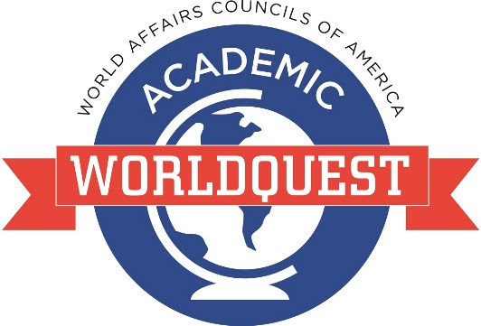

Hosted by the Alaska World Affairs Council
Dena’ina Civic & Convention Center
Saturday, February 11th, 2017 5:30pm – 9:00pm

APPLICATION FORM

______________________ High School would like to send ___team(s)** to the 2017 Academic Student WorldQuest Competition.

_____ We understand that the application deadline is Friday, January 13th, 2017 and team applications received after that date are not guaranteed space.

School/Organization Contact Person:

Name: __________________________________________________

Phone: __________________ Cell : __________________

Email: __________________________________________________

Mailing Address: _____________________________________________

City: ___________________ State: _______ Zip: _____________

_____ I have attached (or will provide prior to the competition) a list of the students participating in the competition and their expected year of graduation.

Please email, fax, or mail your completed application to:

Kari Gardey: kari.gardey@alaskaworldaffairs.org
Fax (907) 276-8818 Phone (907) 276-8038
Alaska World Affairs Council
406 G Street Suite 207, Anchorage, Alaska 99501
**Up to 4 teams allowed per school. There may be room for additional teams. Please contact Kari if you are interested in bringing more than 4 teams.

